# Hungary – Script Instruction

**URL:** <https://magyarkozlony.hu/>

## Initial Setup

1. Open the URL.
2. On the landing page, click Jogszabálykereső (Law search).

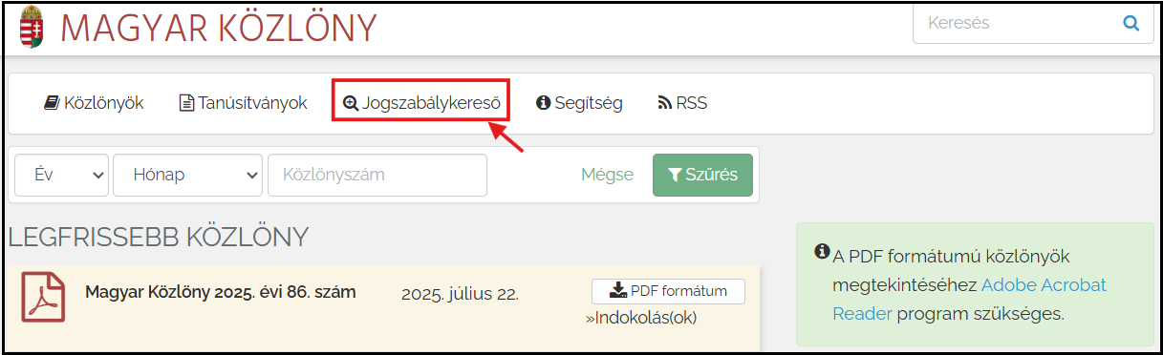

1. You will be redirected to the [National Legislation Database](https://njt.hu/) of Hungary.

## Advanced Search Setup

1. On the landing page, tick the boxes csak hatályos (only valid) and csak címben (only in the title).

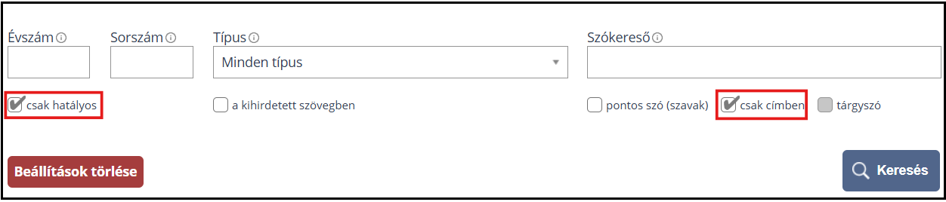

## Extraction of Metadata

1. After setting the filters, enter Hungarian keywords into the Szókereső (Word Search) field with quotation marks then click Keresés (Search) button. (*Please refer to the list of keywords file.*)

1. For example, entering “törvény a számvitelről” (Accounting Act) returns 1 result. (Note: The screenshot below has been translated into English using the browser’s built-in Google Translate for easier reference.)

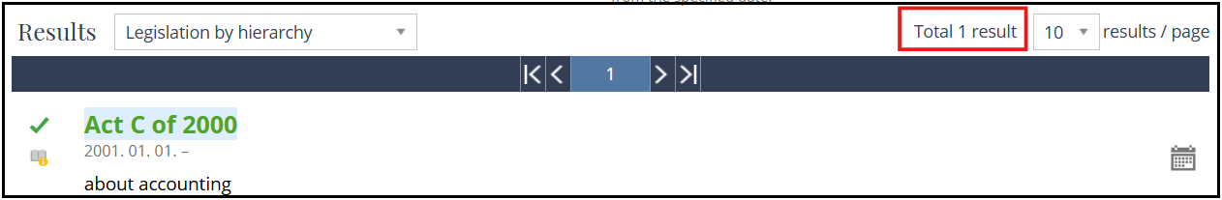

1. The search result already displays the metadata; however, the date of adoption is not included.
2. Extract the following metadata on the search result:

**Source Link** – retrieve this from the hyperlink embedded in the short title, labeled in red.

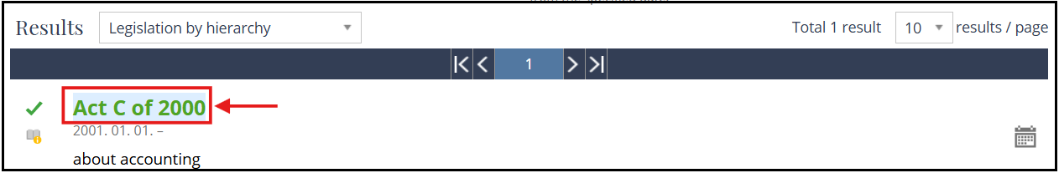

**Original Title** – combine the short title and the long title to form the complete title, as shown below.

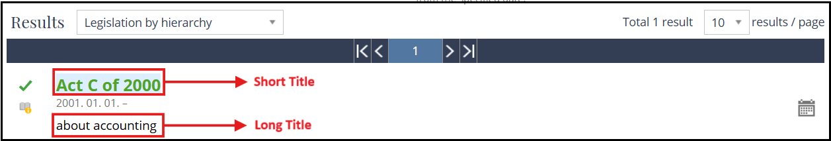

In this case, the original title will read as:

English: “*Act C of 2000 about accounting*”

Hungarian: “*2000. évi C. törvény a számvitelről*”

**Type of Regulation** – capture the type of regulation from the short title, labeled in green, with the following terms:

* törvény (Law)

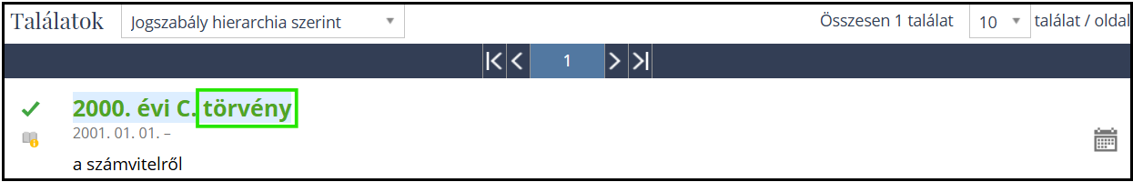

* Korm. rendelet (Decree)

* törvényerejű rendelet (Decree-Law)

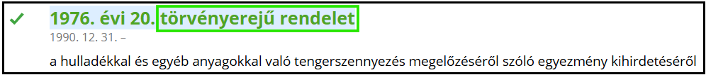

* Korm. határozat (Resolution)

* Határozat (Decision)

**Date of Adoption** – please use the entry into force date information, as explained below.

**Entry into Force Date** – the date below the short title, labeled in purple. The date format in the platform is in YYYY.MM.DD. You should change this to YYYY-MM-DD in the output.

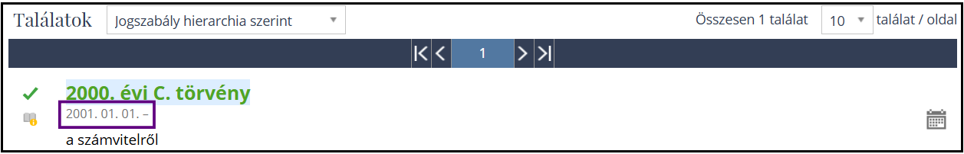

## Important Reminders

1. Duplicate titles and/or source links should be removed and retain one copy of each duplicate.
2. Follow this date format for consistency – YYYY-MM-DD.
3. Please translate all the type of regulation column into English:

* törvény = Law
* Korm. Rendelet = Decree
* törvényerejű rendelet = Decree-Law
* Korm. Határozat = Resolution
* Határozat = Decision

1. Add one column beside the Original Title and translate the titles into English.
2. Please exclude any legislations containing the following Hungarian terms in the title:

* módosítás (amendment / amending)
* előirányzat (appropriation)
* költségvetés (budget)
* visszavonás (repealed)
* visszavon (revoked)
* repülőtér (airport)
* légitársaság (airline)
* kinevezés (appointment)
* kijelölt (appointed)
* beteg (patient)
* koronavírus / COVID-19

For any queries, issues, or clarifications regarding these instructions, kindly post them promptly on our Teams channel so we can provide a timely response or action as needed.

[ESG KLI Project | ESG KLI Project | Microsoft Teams](https://teams.microsoft.com/l/channel/19%3A2cb71aBrx0vDiOIeb2XNrxxCN2EoVFDjq_GOAxRevDY1%40thread.tacv2/ESG%20KLI%20Project?groupId=6f8eb5d6-d2c9-4fe4-a2b2-16b14d6fcc9a&tenantId=be92c534-7b60-4630-bc01-ec5122548d47)